Explore | Your Task
How much do you know about Hannukah? Take a fun quiz to test your knowledge. Write your score here:  Hanukkah Quiz  Do you want to try another quiz?  Take another quiz to test your knowledge. Write your score here:  Quiz 2  _______________________________  In this space write what you know about the Hanukah. | Write a list of 7 words associated with Hannukah here:  Create a new drawing. just go to File, New, Drawing and name it Hanukah)  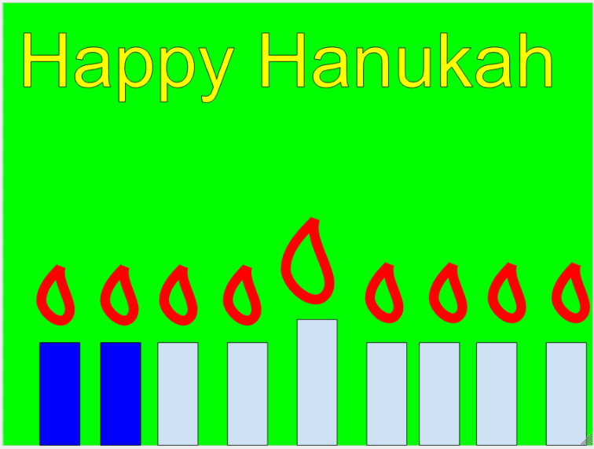
Explain | Your Task
Creating your own Google Drawing can be so much fun. We will learn to use:  - Wordart  - Images  - Shapes  If you want to print your card, share it with me when you are done. csetton@barkaionline.org | - Replace the name of the Untitled doc to your name and Hanukah  - Click Insert, Wordart and type “Happy Hannukah”  - Change the size and color  - Insert shapes to create a Hanukiah or other Hannukah items.  - Insert an image from this button for other pictures  - Write the card to a parent or someone you love and make sure to sign your name.

Reflect! | Reflection Space
This is just one way to demonstrate what you have learned, but there is one more step… | In this space you will write your reflection of this process. Please type your answers in a different color!  - What did you learn about Google Drawing?  - What did you like about Google Drawings?  - What were the challenges you dealt with?  - How did you solve the challenges?

You are all done! Now all you need to do is ‘turn in‘ this Doc to me by clicking the “Turn In” button on the top right side of the toolbar! Be SURE you “MARK AS DONE” in the Google Classroom space after you have turned it in!

If you turned in the assignment and there is still more time:
Ask for permission to take headphones and watch a video.
http://www.g-dcast.com/chanukah/#

